Program Assessment Form

Patients name: | D.O.B: | Health Card#:

Primary Diagnosis if known:______________________ Date of Diagnosis:__________________________

Individual aware of Diagnosis: Yes No Prognosis: Yes No Does Not wish to know: Yes No

Family aware of diagnosis: Yes No Prognosis: Yes No Does Not wish to know: Yes No

Anticipated Prognosis: < 1 month <3 months <6 months <12 months uncertain
Prognosis determined by: (Physician name and phone number)______________________________________________

Resuscitation Status: Do Not Resuscitate order on chart Yes No status unknown
Discussed with: Individual Yes No Family Yes No

Please list all service providers currently involved:
Name: | Contact Info: | Frequency
Doctor:
CCAC:
Nursing:
Other:

List all Family/informal caregiver:
Name: | Relationship: | Contact info: |  | Type of support:

Is there a legal power of Attorney: Finances Yes No List Name and Contact info if yes:_____________________
Is there a legal power of Attorney: Personal Care Yes No List Name and Contact info if yes:______________________

Physical Assessment:
- Level of Consciousness (alert, drowsy, stupor, unconscious) __________________________

Orientation: time , place , person

- Pain
Location of Pain: mark on diagram

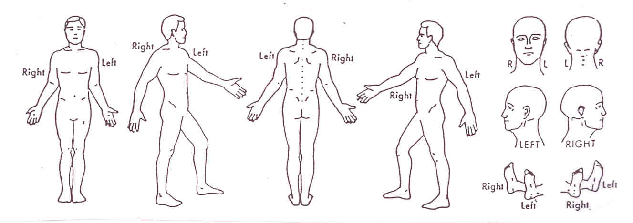

Level of Intensity (1 to 10): at present_______________________________________

After medication___________________________________

Acceptable functional level ___________________________

Quality of Pain (dull, sharp, burning, aching, etc.):_______________________________

What Increases Pain (movement, eating, etc.): _________________________________

What Relieves Pain (medication, change of position, etc): ________________________

Effects of Pain: nausea ______________________________________________

sleep ________________________________________________

appetite ______________________________________________

physical activity _______________________________________

relationship with others (irritability) _________________________

emotions (anger, helplessness, crying) _____________________

concentration _________________________________________

Comments re. Pain: ________________________________________________________

________________________________________________________________________

- Gastrointestinal

Diet: Regular , Soft , Liquid

Supplements: ________________________, flavour preferred: _____________________

Tube feeding: _________________, Loss of appetite: _____________________________

Personal likes and dislikes: __________________________________________________

Body type: Average , Obese , Overweight , Cachectic

Recent weight gain or loss: __________________________________________________

Sores in mouth/throat: ______________________________________________________

Difficulty swallowing/chewing: ________________________________________________

Nausea:
Contributing factors (i.e. food, smells, meds): ____________________________________

Medications used: _________________________________________________________

Vomiting: ________________________________________________________________

Current Management: ______________________________________________________

Bowels:
Constipation , Laxative/Supp used: _____________________________________

Diarrhea , Med used: ____________________________________________ _

Colostomy

Incontinent

Bladder:
Frequency Burning Nocturia

Incontinence Catheter

Comments: ______________________________________________________________

________________________________________________________________________

________________________________________________________________________

- Skin
Rash Dryness Itching Ascites

Open areas Bruises Edema

Comments: ______________________________________________________________

________________________________________________________________________

- Respiration
SOB Wheezy Cough - production

Dyspnea Smoker Uses 0₂

Comments: ______________________________________________________________

________________________________________________________________________

- Sleep/Rest
Fatigue Insomnia Sleeping aids (i.e. Rx, milk) ____________________

Comments: ______________________________________________________________

________________________________________________________________________

Psychosocial

Reaction to Diagnosis: Anger Denial

Anxiety Depression Frightened

Comments: ______________________________________________________________

________________________________________________________________________

Problems created by Illness: (family, finances, lifestyle, employment)

________________________________________________________________________________________________________________________________________________________________________________________________________________________________________________________________________________________________________________________________________________________________________________________________________________________________________________________

Where would you like to be cared for? (Home, Hospital, Other)
________________________________________________________________________________________________________________________________________________________________________________________________________________________________________________________________________________________________________________________________________________________________________________________________________________________________________________________ ________________________________________________________________________________________

Can your Family help in the support of your care? List family member who can provide care
If Required:

Assist with administering medications: Yes No N/A If Yes list family member(s):____________________

Meal Preparation: Yes No N/A If Yes list family member(s):____________________________________

Bathing and skin care: Yes No N/A If Yes list family member(s):________________________________

Toileting: Yes No N/A If Yes list family member(s):__________________________________________

Transferring: Yes No N/A If Yes list family member(s):_______________________________________

Safety Check: Yes No N/A If Yes list family member(s):_______________________________________

Respite and alternate care providers: Yes No N/A If Yes list family member(s):_____________________

Other: Yes No N/A If Yes list family member(s):_____________________________________________

Training required for family: Yes No (if yes see narrative notes and care plan)

Religion:

Religious Affiliation:_____________________ Clergy Name:________________ Contact #:______________

Would you like a clergy visit? If Yes when?_____________________________________________________

Traditional Care: What Traditional Services are you receiving or would like to receive?

Smudging___________ Traditional Healer________________ Traditional Meds_______________________

Other:__________________________________________________________________________________________________________________________________________________________________________________________________________________________________________________________________________________________________________________________________________________________

Special Care Requests: ________________________________________________________________________________________________________________________________________________________________________________________________________________________________________________________________________

Does Client Meet Criteria For Wiisokotaatiwin Program:
- PPS score of 60% or lower Yes No
- Client has illness from which no recovery is expected and it would not be surprising if they passed within one year Yes No
- Client could benefit from the services of the program Yes No
- Client wished to be part of the program Yes No

Client admitted to Wiisokotaatiwin Program: Yes No
EDITH protocol initiated: Yes No If No explain why:_______________________________________

Client or POA signature:__________________________________________________________________

